Community is the best medicine funding

Increased costs this year are going to leave many people across our communities with additional cost burdens that may prove to be extremely challenging. Households may be faced with choices between eating healthily, turning the heating on or having to live in cold homes, leading to increased health and wellbeing issues.

South Staffordshire Council in Partnership with the Midlands Partnership Foundation Trust (MPFT) and The Staffordshire Community Foundation have pooled a budget to facilitate this provision. It is not intended to cover the full costs, rather supplement other budgets and funding that existing organisations are already using for this type of provision.

The funding is to respond to increased pressures and the demand that is likely to arise from existing community support provision. The funding will be utilised for a variety of purposes including:
- To support and promote the provision of a network of warm and welcoming spaces for any in our community / communities to go to on a regular basis
- Bespoke support packages offered by community groups to those most in need. As the cost-of-living increases (i.e. heating, food price inflation, housing costs, other costs, etc.) this will start to impact on our residents daily lives. Visitors to these locations would be able to receive a friendly welcome, someone to talk with and be listened to, whilst having a warm drink. & food in venues that are equipped to offer this facility. Food and drink maybe be offered free of charge depending on their individual’s circumstances and the resources available to the provider.
- Befriending and support for those most vulnerable in our communities including those who experience rural isolation.
- To provide support packages that are bespoke for individual communities.

Criteria for Accessing Funding:
- Demonstrate increased demand on existing provision of support services that cannot be contained / met from existing resources
- Funding will be seen as a contribution to additional costs
- Applicants will need to be an established or constituted group
- Support to new initiatives that are targeted to supporting people with the cost of living
- Small Local Business can apply for funding if providing additional support to the most vulnerable at no or a reduced cost

Funding Principles:
- Maximum of £1,000 limit of funding however the Council have the discretion to increase contribution if need can be demonstrated.

- The council will utilise local data and intelligence to inform decisions on funding applications.

- Due to the districts geography there may be venues across the border which are better placed to offer support to our residents, due to their size , accessibility or host well established groups that can alter their operating model quickly to accommodate a warm space. Funding for groups / organisations outside of the district will be eligible on the basis that they can demonstrate the need for South Staffordshire.
- It is also anticipated that some Parish Councils / partners and local community groups may want to add additional funding to support the needs of their residents during these unprecedented times. This may grow the number of Warm Spaces, services offered or core service offering.

Application for Community is the best medicine funding
1. Name of group or organisation

2. Contact Name

3. Contact number

4. Contact address

5. Email

6. Organisation Type: |  | Not for profit organisation
 |  | Community Interest Company
 |  | Other – please specify:
7. Project title / Name

8. What areas within South Staffordshire will your projects focus on? Whole district, locality, Parish, Ward or village.
Please use locality map on the back of this form

How does your project/organisation make a difference?
Please include any data you have collected yourselves as supporting evidence and further data to support your application can be found in the Locality Profile for South Staffordshire 2018
9. Your group/organisation’s involvement in your local area
Tell us about your organisation and how they have or will support the residents of South Staffordshire?
up to 300 words

11. Why is your project/service/activity needed?
Provide evidence to tell us why you think your project is needed.
How will your project help to strengthen the local community?

Part Two
The Finances
12. Project Expenditure
Below please outline the costs associated with your project
If this is a new initiative how much will your project cost?

Please provide a full breakdown

Item or Activity | A  Total Cost | B
 | £ | £
 | £ | £
 | £ | £
 | £ | £
 | £ | £
 | £ | £
Total Project Expenditure | £ | £

If this is an established group / project, please demonstrate how there has been an increased demand on existing provision of support services that cannot be contained / met from existing resources.
Please tell us how the cost-of-living crisis has impacted your organisation and how it is preventing you from running your group / project.

Part Three
13. Project Income
Does/will your project be requesting/receiving funding from elsewhere
Have you applied for funding towards this project from elsewhere (other than South Staffordshire Council) or are you able to contribute funding from your own organisation?

Please list below any other funding source other than South Staffordshire Council.
Please also include any in-kind or volunteer contributions.
Funding Source | Amount
 | £
 | £
 | £
 | £
Total Project Income | £

Declaration (on behalf of organisation or group)
I can confirm that
I have read the funding criteria
The information on this form is correct
Any award received will be spent on the activities specified
If an award is received I will complete and return an evaluation sheet along with supporting photos or video footage.
That acknowledgement will be given of South Staffordshire Council’s support in any publicity, printed or website material.
I give permission for press and media coverage by South Staffordshire Council in relation to this project.
That all press releases issued by us will be cleared through South Staffordshire Council
That the necessary policies and procedures will be in place prior to the commencement of the project outlined in this application

Signed ………………………………………………………………. Date………………………….
Print Name …………………………………………………………………………………………………….
Position within the organisation ……………………………………………………………………
Bank account details: …………………………………………………………

Please return your completed application by to:
Applications for funding are to be submitted through the Locality Enablers:
- Maggie Quinn – m.quinn@sstaffs.gov.uk
- Ryan Taylor – r.taylor2@sstaffs.gov.uk
- Andy Aston – a.aston@sstaffs.gov.uk
- Harvey Bains – h.bains@sstaffs.gov.uk
- Rob Sharratt – r.sharratt@sstaffs.gov.uk
- Lead Enabler for the scheme: Ryan Creswell – r.cresswell@sstaffs.gov.uk

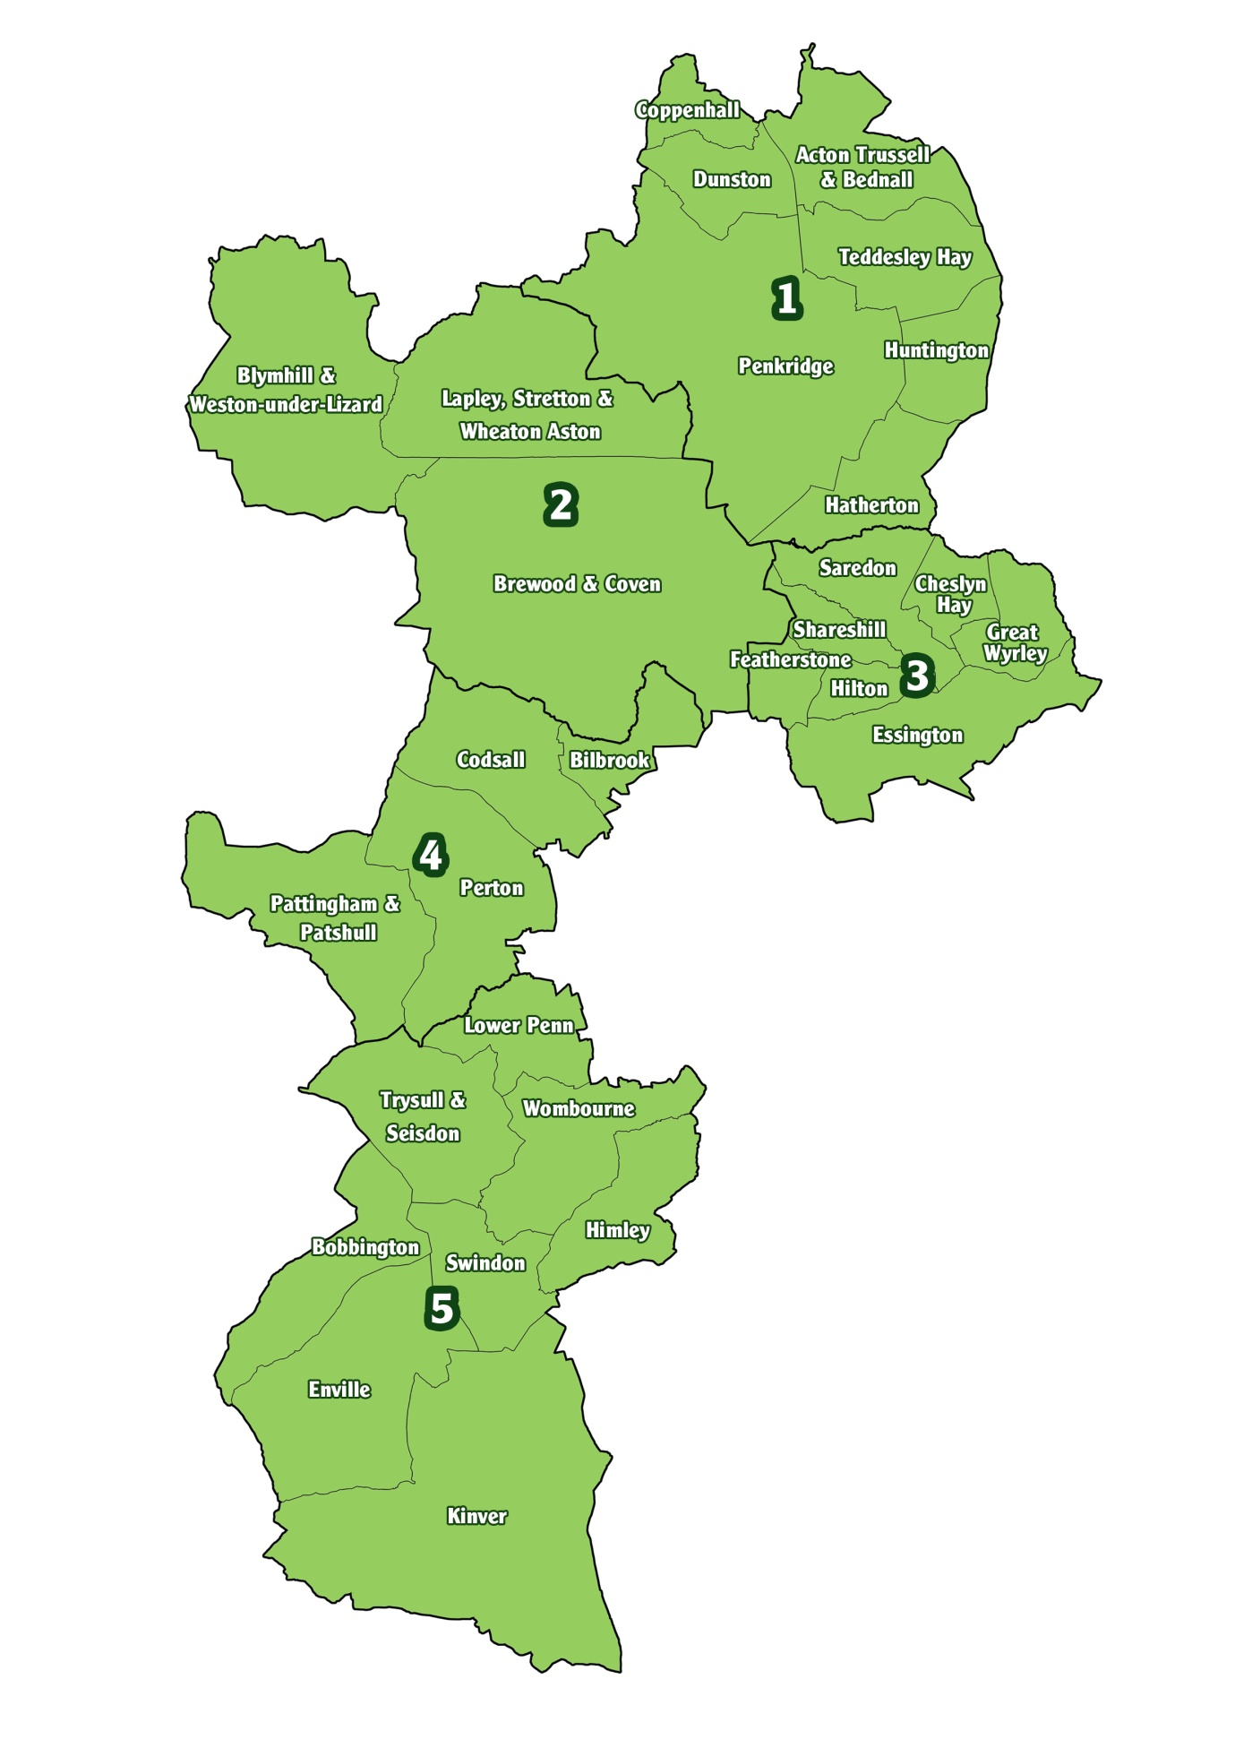
South Staffordshire Localities Map

