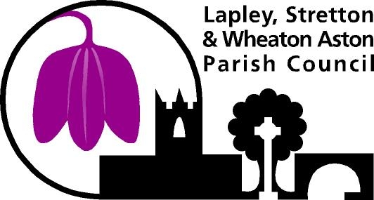

**Graffiti Management Policy**

**PURPOSE**

The purpose of this Policy is to provide a framework for managing graffiti and to support the governments plans for a cleaner, greener county <https://www.gov.uk/government/publications/environmental-improvement-plan>

LSWA PC promotes respect for the environment and will strive for a Cleaner, Greener, Sustainable and Safer Environment.

This policy seeks to improve the street scene and reduce the fear of crime, for the benefit of all those who live in, work and visit the parish

LSWA PC will work with Agencies and Utility Companies to reduce graffiti on street furniture and other apparatus.

LSWA PC will work with the Police and other organisations to reduce the occurrence of graffiti

# POLICY INTENT

LSWA Parish Council recognises the significant community impact of graffiti and will minimise and manage the impacts of graffiti through the implementation of the Graffiti Management Program.

The main objectives of this policy are to:

1. Minimise the incidence of graffiti on public property.
2. Reduce the impact of graffiti on residents and business operators.
3. Increase quality of community life in relation to personal safety and security.
4. Reduce the financial impact of responding to graffiti.

# POLICY

The Council’s approach to graffiti management is based on the following principles:

* Prevention - Reducing unacceptable levels of litter, detritus, fly posting and graffiti forms a key part of Government’s ‘Cleaner Safer Greener Communities’ Strategy.
* Eradication – LSWA PC has a duty to remove graffiti from its own property, just as the maintenance of privately owned items of street furniture is the responsibility of their respective owners.
* Detection and reporting – LSWA PC is committed to making the parish a Safer, Cleaner and Greener as detailed in the Anti-Social Behaviour Act 2003 and the Clean Neighbourhoods and Environment Act 2005
* Enforcement - Under certain circumstances, Graffiti is classified as a criminal offence under the Criminal Damage Act 1971. The Police Service is the only enforcement agency with the legislative powers to prosecute an offence of Criminal Damage
* Community information and education – LSWA PC will publish this policy on the Council’s website and will work with other agencies to reduce graffiti in the Parish. When asked to do so, the Parish Council will advise members of the public on whom to contact regarding graffiti removal from private property.

The Council will respond to graffiti within the Parish via the following strategies:

# Reporting Graffiti

LSWA PC will encourage the community to report incidents of graffiti to the Parish Council Clerk online or over the phone – [office@wheatonastonparishcouncil.gov.uk](mailto:office@wheatonastonparishcouncil.gov.uk) / assistantparishcouncil.gov.uk 07495789051/ 01902 327091

# Prioritisation of Graffiti Removal on The Council Assets

Removal of graffiti on LSWA PC assets is prioritised based on the type of graffiti, with priority given to the removal of offensive, racist or defamatory graffiti and/or graffiti on prominent sites or sites of significance within the community.

**GENERAL STATEMENTS AND DEFINITIONS**

Definition of Graffiti: Graffiti can include drawings, scribbles, messages or ‘tags’ that are painted, written, sprayed or etched on walls and other surfaces.

Definition of Offensive Graffiti: Offensive Graffiti is illegal and unauthorised and may contain some or all of the following elements: • Offensive language

• Language of a political, radical, religiously insulting or inciting nature

• A graphically explicit image

• Any statement declaring hatred of any person or group

The following table outlines the graffiti removal timelines on LSWA PC’s assets depending on the type of the graffiti.

|  |  |
| --- | --- |
| **TYPES OF GRAFFITI** | **PRIORITY REMOVAL TIME** |
| **Type 1**  Racist, defamatory, offensive graffiti on The Council assets and/or prominent sites or sites of significance. | As soon as practically possible from when it is reported. |
| **Type 2**  All non-offensive or other types of graffiti. | Within one week of it being reported |

**PLEASE NOTE: Timescales based on staffing and weather conditions.**

# Graffiti Prevention

LSWA PC aims to reduce graffiti through a community development approach that engages the community and partners with other levels of government, local businesses and the police.

# Removal of Graffiti on Private Property and other Local Authorities

LSWA PC does not remove graffiti from private property. The Council will only remove graffiti from Council owned assets. Residents are encouraged to report Graffiti incidents to the Police and the property owners.

The Clerk will signpost residents to the correct Local Authority when a graffiti incident involves the property of a local authority.

# REVIEW

This Policy will be reviewed every year from the date of adoption of the policy, or more frequently as required.

Adopted January 2024

Revised January 2025